The Latter Rain
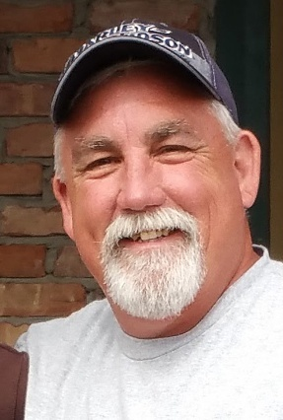
Greetings Family !
Blessed be the name of the Lord, Jehovah-Jireh, “The Lord is our provision” He provides The Former and the Latter rain. God is faithful to show us our spiritual provision and future by the example of the things He has made. As He gives the former rain in fall to prepare the ground for sowing, He is then faithful to bring the latter rain in spring and summer to make the crop thrive and mature. Joel chapter 2 talks about restoration and abundance because of God’s mercy and provision. We can be so prone to making idols out of our own pride, creating a counterfeit prosperity that does not take into account the cost of our souls. As we come together at Courageous House, we are learning to trust God for His wisdom in what we need and when. Patience and Endurance, James 5:7 Dear brothers and sisters, be patient as you wait for the Lord’s return. Consider the farmers who patiently wait for the rains in the fall and in the spring. They eagerly look for the valuable harvest to ripen. You, too, must be patient. Take courage, for the coming of the Lord is near. James goes on to encourage the believers in their (our) relationships to be an example in our waiting. We are learning to reject the temptation to fashion a religious house of cards that will not stand in the face of trial and adversity. Paul affirms the richness of growing in our relationship with Him and one another Colossians 2:6-7 And now, just as you accepted Christ Jesus as your Lord, you must continue to follow him. Let your roots grow down into Him, and let your lives be built on Him. Then your faith will grow strong in the truth you were taught, and you will overflow with thankfulness. We are so thankful to celebrate 12 years of the body of Christ who through Him, has consistently been a source of provision and encouragement for us to do just that.
Joel 2:23-27
Rejoice, you people of Jerusalem! Rejoice in the Lord your God!
For the rain he sends demonstrates his faithfulness. Once more the autumn rains will come ,as well as the rains of spring. The threshing floors will again be piled high with grain, and the presses will overflow with new wine and olive oil.
The Lord says, “I will give you back what you lost to the swarming locusts, the hopping locusts, the stripping locusts, and the cutting locusts. It was I who sent this great destroying army against you. Once again you will have all the food you want, and you will praise the Lord your God, who does these miracles for you. Never again will my people be disgraced. Then you will know that I am among my people Israel, that I am the Lord your God, and there is no other.
Never again will my people be disgraced.

Lester Berry
From the Courageous House Garden,
We are learning from practical example, that proper cultivation, sowing good seeds, nourishing and watering produces the fruit of a beautifully sustained life !
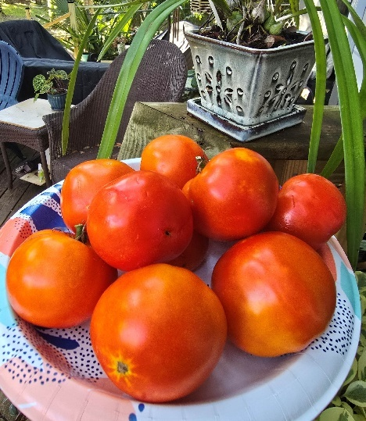
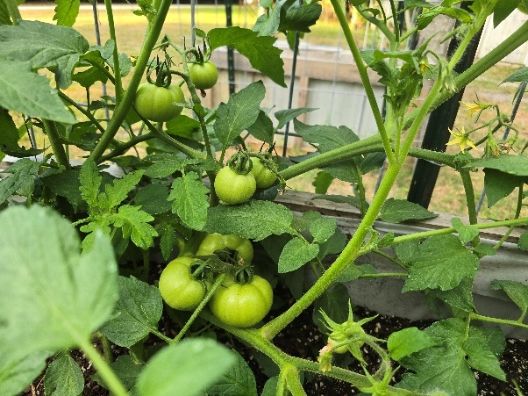
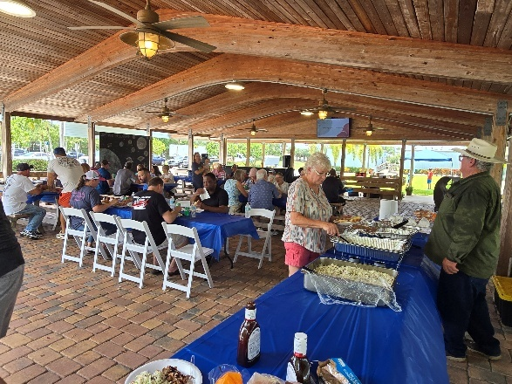
What a wonderful day of Celebrating
12 years of God’s Faithfulness!
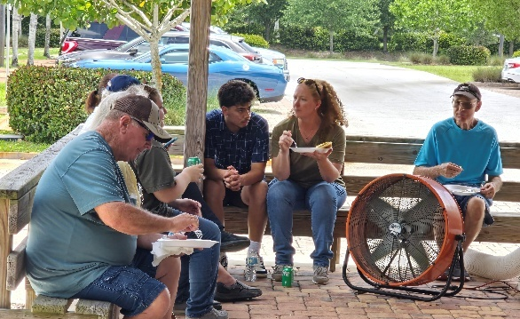
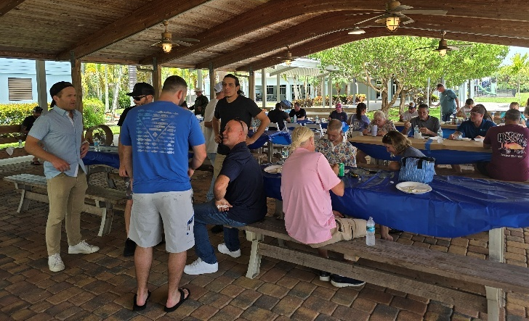
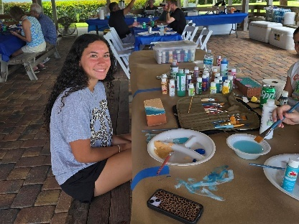
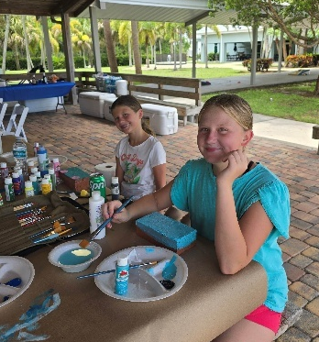
Thank you
Everyone for the
beautiful fellowship
and wonderful
memories made!

You make an incredible difference. Please be encouraged as some of the
men share their journeys of faith and hope!
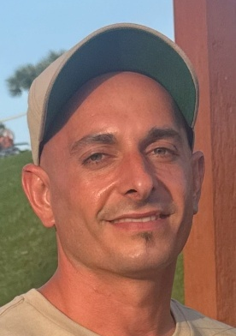
Kam Leone, Resident Manager
My name is Kameron Leone and like most of the men on this page. I too come from a dark past, where I found no hope. I truly believe I was not going to see 25 years old. I was in bondage, and I didn’t think that there was any way out. But God is good, and he heard my cries. He is a miracle worker. God made a way for me. I just got to celebrate my 32nd birthday I was surrounded by my family friends and loved ones but most importantly I was surrounded by the body of Christ. I would never have imagined my life looking the way it does today. My life is rich, and it’s all because of God’s grace and mercy. Five years ago, I went to Dunklin where I started to build a relationship with Christ and that is where He began to change me from the inside out. A couple months into Dunklin I started to recognize and hear his voice more clearly. I will never forget the time he told me son “you will be in ministry”. As I progressed in my walk that calling got louder and louder. After graduating Dunklin I stayed for some time and eventually became a staff member. I thought that I was going to be at Dunklin for a while, but then I heard the Lord speak to me again this time he told me to go and serve at Courageous House and that is where I am today. I truly know that this is where the Lord wanted me to be. I get to be a vessel for God serving his Kingdom and helping others see the light of Christ. There is nothing better than to see a man be transformed by the Lord and to learn how to become a disciplined follower of Christ. Although this journey is not easy, I am blessed and honored to be in the battlefield with these men. Proverbs 14:12 there is a way that appears to be right but, in the end, it leads to death. Proverbs 16:9 A man makes his plans, but God directs his path. The path to life! Kam Leone
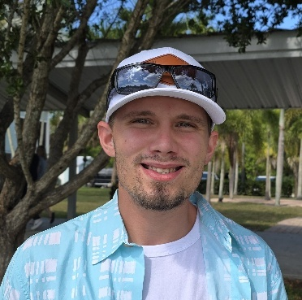
Matthew Bass I came to Courageous House after being excused from the Dunklin program. I have made some mistakes, but I have grown a lot. I’ve learned to set goals and accomplish them little by little. God has restored my relationship with my family He is teaching me how to be a father. My son Brayson used to cry every time I picked him up to spend time with him now, I can make good memories with him and my mom tells me that Bryson called to see his dad. The Lord has turned my life around and I’m finally letting him work in me. I’m learning how to slow down and set boundaries to help me from slipping into bad relationships or risky situations and not getting mixed up in the temptations of the world. I’m committed to another year at courageous house I am enjoying my walk with Christ letting him show me new things in life learning to enjoy the time with my boys and just to see the joy inside them to have their father back. I am thankful for the brothers who have come through the house that have shown me how to be a leader and better father. I have committed to another year of letting God work in my life here at courageous house I have a vision of one day having my own place where all my boys can be with me play playing in the yard having fun Matt Bass

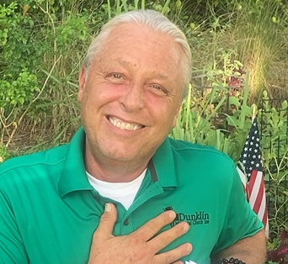
Christopher Slater
A lifetime of bad decisions and I woke up yet again in jail from another blackout not knowing if I killed someone for drinking and driving and using chemicals. Through the grace of God I was able to make application for the Dunklin outreach program at the Martin County jail, There I met with Lester, and he accepted into the program. From that point on I took it very seriously. I looked at what men told me about myself from 8 to 4:00 every day for a year, with the journaling and the sociograms and learning how to build and develop relationships and how to receive accountability, I knew that’s what I needed to help me stay sober. When I was released, I was accepted to the Courageous House December 16th, 2016, I made a 6-month commitment, I ended up staying for 27 months. I was on local probation felony probation and federal probation, and I knew that if I didn’t have serious accountability in my life I would be going straight to prison. There’s just so many people who poured into me at the Courageous House. I learned how to slow down and be open to receiving accountability, remaining humble, and learning how to build solid relationships and understand that there are men who truly love me and wanted to see me do well. One of my fondest memories and something that really I really cling to today is, after being there two weeks, I had my look good on, you know “Mr. nice guy” trying to help everybody and it was in one of our Monday night meetings and someone had held me accountable on something and I said something so vicious, I can’t even remember what it was at the time, but one of the brothers stood up and approached me and he said nice to finally meet you man we’ve been waiting to meet the real you and here you are now. So all the facades are over, now we can get to work, now let’s see what you’re about. They told me one day later on that I owe a debt and the debt isn’t to them and it may not need to be paid today or tomorrow but at some point in the future I’m going to get the opportunity to reach out and help someone myself and I’d like to say that I’ve spent my years since the Courageous House trying to help as many people as possible. I just want to say Lester I love you so much I love everyone behind the scenes who has poured into me and thank you. I’m really happy today. I do believe this will be the 12th anniversary benefit and I’m just so happy and proud to be associated with the Courageous House. Thank you very much and…….. I’m still looking forward to this Christmas, to maybe win the golden spatula love y’all Chris Slater


Kai Blood
Hey guys, my name’s Kai Blood. I went to Courageous House in 2021. How I got there is a wild story. I got out of prison shortly before going to Courageous House. I had gone to prison leaving my wife and my children alone. When I got home, I did my best to be the provider and nurturer that I could, but I fell short. The reason I fell short is because I tried to do everything on my own esteem and my own power. I tried to bring my family back together and ended up just ruining it and I fell back into addiction. I started using fentanyl and my fentanyl addiction was progressive, and it did not only affect me, it affected my wife as well. I dragged my wife down and it also affected my kids greatly. My kids witnessed my wife, and I destroy our lives with overdose and incarcerations. I had some people in my life who were alumni of Dunklin and Courageous House who were pushing me to go to Dunklin or Courageous House, and I just wasn’t in a spot to bring the Lord into any kind of situation that was in my life. I was against it all. I didn’t have a relationship with Christ I really didn’t even know who he was. I went to detox and tried to get into Dunklin. They were worried about who was going to take care of my children so they led me to call Matt Hubley and Lester Berry at Courageous House, so I made the first contact, and they welcomed me open arms into Courageous House. I remember my first day there, I already knew that I was around different types of individuals. They were ambassadors of Christ, they were welcoming and loving but they also spoke truth to me and they were stern and they held rigid boundaries and so I immediately respected them and felt welcomed. It was tough, I was coming off a large dose of methadone, so I was very sick, and it was really hard for me to acclimate but again I was surrounded by men who loved me and who loved Christ, so I was able to get through it. I remember the Lord speaking to me and as I was cleaning out the house he was cleaning out my heart and it was a very powerful moment for me and it really strengthened my spiritual legs and my spiritual eyes and I really started to grasp what Christ was doing for me and I remember in that moment the cross wasn’t foolish to me. I started to feel better, I felt like I felt like the Lord had a purpose in my life and I felt like my process and growing was over. I didn’t heed my conviction, and I didn’t heed my spiritual authority, so I ended up leaving. I ended up making a bigger mess than the mess I had made before going to Courageous House. It only took me it took me little to no time to be right back in the streets using fentanyl again. I was at my wits end, my wife was at her wits end, we’re both at the end of ourselves. She ended up getting arrested, and I ended up going to detox again for the second time. I miraculously made it to Dunklin. I began to thrive again, I was digging into the word, and I was being poured into. I was very unsure of what my future looked like. I remember surrendering my wife I to the Lord over and over. Five months after being at Dunklin my wife and my children were sitting with me in the Tabernacle at Dunklin Memorial Church. I remember being so broken under all of God’s grace. I’ve been at Dunklin now for three years. My wife and kids have been here for two years, my wife and I have been sober for three years now. My wife currently works at a private Christian School, and she is thriving. My children attend the same school, and they are thriving. I’m about to start on the next journey of my life which is going into servant leadership training. I feel like the Lord has put a calling on my life to full time ministry. I always remember the choice I made to leave Courageous House, and that always sticks with me. So, when the Lord’s calling me to full time ministry, I’m going to submit to it and surrender. I’m very grateful for the Courageous House, for the seeds they planted in my life because if it wasn’t for Courageous House I wouldn’t be sitting here today with my family thriving. I’m very, very grateful for the Courageous House and the Lord and what he’s done in my life. Kai Blood
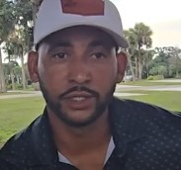
Juan Peguero
We are so grateful for your donations. We are currently in need to complete some necessary repairs and upgrades to the property and residences.
Upgrading our electric service is becoming more and more of a priority to address outdated equipment and to accommodate some moderate growth. $10,000.00
We are in great need of finances to cover these costs. Please pray how you might help us with these projects.
BLESS YOU !
Lester and all the Joshua’s Promise family thank you!
Joshua’s Promise Ministries Inc.
15192 SW Chickee St.
Indiantown, Fl. 34956
lester@joshuaspromise.net
(772) 349-9164
kam@joshuaspromise.net
(561) 801-3357
We are a Registered Non-Profit organization and all donations are tax deductible
When I first arrived at Courageous House I was very grateful that they accepted me even though I wasn’t able to work. I had to get eye surgery because of un addressed diabetes in my addiction. They helped me to do that and I was able to heal up. When I left Dunklin it was the best choice for me. I was able to get over most of my fears After Courageous House, 2 ½ almost 3 years ago on my life today you know I use to pray for this and pray for that and if I would have got what I wanted at that moment I wouldn’t have the life that I have today. I have a great job I have great relationships around me. The Lord made a way for me to be able to be in my family’s life and see my niece. I see my sister and talk on the phone with my dad, things that I wouldn’t do before. The Lord really has done a miracle. In 1 Corinthians 29 it says; no eyes have seen no ears have heard no human mind has conceived the things that God has planned for those who love him. That is the truth in my life today.
Juan Peguero

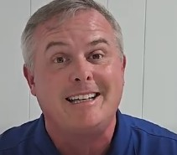
Mark White
After many relapses I kept going to many different places I was fighting against everything that the Lord was wanting me to do the Lord want me to just sit there and just give up and look at Him instead of my own ways because every time I got things in my life I would have this white knuckle pressure because it wasn’t from Him. I thought it was from me because that’s how self-centered and selfish I am. I did surrender and was blessed enough to come to the Courageous House. Courageous House is much different than any other halfway house per se that I’ve been in before. you know here I was able to come and meet outward life with the support of Courageous House which taught many of the teachings from Dunklin while I was there I was able to develop a real relationship with the Lord. I just finally just sat there and started hitting my knees I started I started making a point in my day to sit there and start my day with my relationship with the Lord from there it just blossoms I have been blessed after my time there at Courageous House. I was there for seven months. I graduated and moved out I now live by myself and I have been for a couple of years. I’m getting ready to hit two years sobriety July 28th I’m very excited and proud about that. The blessings that have come into my life are amazing. I’m not going after the big houses or the cars or anything. I’m going to the Lord 1st Matthew 6;33 that’s what I do with everything I do and I’ve been blessed through that. My apartment, through relationships with friends, I have a career back in healthcare now where I’m doing marketing. Now in truly a God moment I’m going back to school for my RN degree and that is only from the Lord because with that degree it takes up a lot of time and a lot of money. There’s a lot of moving parts to try to do this and still work at the same time. The Lord placed people in my life that were able to get me to the spot I am now. I did not get here by myself and I am so happy and so thankful that I finally realized that. Mark White


Chris Irrizary
Starting from high school and then college, that’s really where it all started. I mean I started really drinking. It was part of all of my life. I never knew a moment I did not know somebody around me or I was not drinking. Hispanic families know we know how to party. No time of celebration that there was not drinking. I found out what pain pills were by stealing my mom’s. I got sick as a dog but for some reason it filled up something inside of me that never could be filled up before and after that it was off the rails. I wanted to find out more about this world and this feeling and how I can control it so that’s what I did all my high school just delving deeper and deeper into a lifestyle of debauchery violence I mean sexual morality. It didn’t matter what was wrong, anything and everything to fill up this void that I now knew could be filled. I was doing so much stuff just to avoid the fact that I’m a mess. All the other people around me can recognize that I’m a major mess. I really did not care and that’s when I just started using everyone and everything around me. I had to go back home because I didn’t have enough money. My parents eventually found out that I’m a drunk and an addict. I ended up going into detox about 8-9 times finally with no place left to go. That’s where Dunklin comes in and that’s where the Lord was able to use the opportunity for me to see what He can do in my life. I found out that there was something different in life. I was ready to give it a shot. It’s my last chance because I was already on this path of suicidal tendencies. The Lord exposed me to who He was and gave me an encounter with Him. Despite that I went to the whole program completely, faking it throughout the whole way. I couldn’t see it back then, but my foolishness was just plain idiocy. I see how my perspective of life is just off, and I see that back then the Lord was showing me that. I just wanted to get out of Dunklin that was the reason why I went to Courageous House. Once I got there, I met Matt Hubley and Lester. They’re tough. I want to fight them and I some days I wanted to punch them. I never knew what it meant to have that actual type of accountability in my life. To be out in the real world and have another man tell you what to do is hard but that’s what the description is of walking in and learning true humility is. The Lord’s grace and mercy brought me to Courageous House, my own foolishness and sin got me out of there. When I decided to relapse multiple times over, they would bring me back in and give me another chance and show me the Lord’s love and grace. I just spit on the face of all the people there and the Lord himself. That’s where I learned the true love of God because despite what I did God’s still loves me and He expressed that through the people around me. Even to this day Lester stops on me in the middle of the yard and like it's like greeting a mentor. Despite all I’ve done wrong He still tells me he loves me like I was his own son. At Courageous House, I learned that God is serious about my life. He is firm and full of love. Chris Irrizary

Thank you to all the Alumni men who have shared the hope of God’s faithfulness
Blessings !
Your help to support this ministry is vital.

Men who enter the Courageous House make a one-year commitment. Your donations provide the needs for them to get well established and grow as Godly men. If you are inspired to join in the mission of Gods redemption story, by making a recurring monthly donation or a onetime donation, Please use the QR code.
“Joshua’s Promise Ministries” is a registered nonprofit. All donations are tax deductible.
We love you all ! Thank you for being such an important part of our lives
and the vision that is Courageous House and Joshua’s Promise Ministries.

